Computer System

What is a computer system?
- A computer system is made up of hardware and software components and is capable of:
  - data input – using input devices
  - data processing – using a microprocessor, typically the Central Processing Unit (CPU)
  - data output – using output devices
- It may also be capable of:
  - data storage – so data can be stored for later use
  - data transmission – so data can be transferred to or from another computer system
As well as the personal computer, this definition applies to any equipment which uses computer technology.

What is hardware?
Hardware refers to any component that has a physical presence and can therefore be touched. Hardware devices can be divided into five types:
- Input Devices – these include any kind of device which can be used for getting data into the computer system from the outside world. Some examples include; keyboard, mouse, microphone, heat sensors, switches, touch screens, digital cameras and so on.
- Processing Devices – this usually refers to the Central Processing Unit (CPU) which carries out program instructions.
- Storage Devices – these include any device which will store data until it is needed for processing. This can include temporary storage devices, like the computer’s memory, or long-term storage devices like hard-drives, DVD drives or tape drives, etc.
- Communication Devices – these deal with the transfer of data from one computer system to another and include routers which link networks and modems which allow computers to communicate data via the Internet.
- Output Devices – these include any devices which can provide data in a useful format to a user. For example a computer monitor, speakers, printers etc.

The diagram below gives some examples of these different types of device. The arrows show how data can be transferred between them in a computer system.
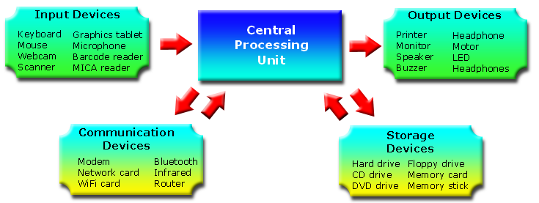Typical hardware components and how they are linked

Peripheral Devices
These are hardware devices which fit into one of the above categories but are external to the main body of the computer. They are typically connected by cables (USB, network, Firewire etc.) or wirelessly (Bluetooth, wireless network links etc.). Examples include keyboards, mice, scanners, printers, external hard-drives etc.

